Semester One Examination 2018

Question/Answer Booklet

MATHEMATICS SPECIALIST
UNIT 3

Section One:
Calculator-free

Student Name: _____________________________________
Teacher‘s Name: _____________________________________

Time allowed for this section
Reading time before commencing work: five minutes
Working time for paper: fifty minutes

Material required/recommended for this section

To be provided by the supervisor
This Question/Answer booklet
Formula Sheet

To be provided by the candidate
Standard items: pens(blue/black preferred), pencils(including coloured), sharpener, correction tape/fluid, erasers, ruler, highlighters

Special Items: nil

Important note to candidates
No other items may be taken into the examination room. It is your responsibility to ensure that you do not have any unauthorised notes or other items of a non-personal nature in the examination room. If you have any unauthorised material with you, hand it to the supervisor before reading any further.

Structure of this paper

 | Number of questions available | Number of questions to be attempted | Suggested working time (minutes) | Marks available | Weighting
Section One  Calculator—free | 7 | 7 | 50 minutes | 50 | 35%
Section Two  Calculator—assumed | 11 | 11 | 100 minutes | 100 | 65%
 |  |  |  | 150 | 100%

Instructions to candidates

- The rules for the conduct of Western Australian external examinations are detailed in the Year 12 Information Handbook 2018. Sitting this examination implies that you agree to abide by these rules.

- Answer the questions according to the following instructions.

Section One: Write answers in this Question/Answer Booklet. Answer all questions.

Show all your working clearly. Your working should be in sufficient detail to allow your
answers to be checked readily and for marks to be awarded for reasoning. Incorrect
answers given without supporting reasoning cannot be allocated any marks. For any
question or part question worth more than two marks, valid working or justification is
required to receive full marks. If you repeat an answer to any question, ensure that you
cancel the answer you do not wish to have marked.

It is recommended that you do not use pencil, except in diagrams.

- You must be careful to confine your responses to the specific questions asked and to follow any instructions that are specific to a particular question.

- Spare pages are included at the end of this booklet. They can be used for planning your responses and/or as additional space if required to continue an answer.
- Planning: If you use the spare pages for planning, indicate this clearly at the top of the
page.
- Continuing an answer: If you need to use the space to continue an answer, indicate in the original answer space where the answer is continued, i.e. give the page number. Fill in the number of the question that you are continuing to answer at the top of the page.

- The Formula Sheet is not handed in with your Question/Answer Booklet.

Section One: Calculator–free 50 marks

This section has seven (7) questions. Attempt all questions.
Write your answers in the spaces provided.

Working time: 50 minutes

Question 1 (5 marks)

The polynomial function $f\left(z\right)=2z^{4}-4z^{3}-4z^{2}+16z-16$ has the real solutions $z=±2$
for $f\left(z\right)=0$.

Determine all real and complex solutions of $f\left(z\right)=0$ and then fully factorise $f\left(z\right)$. (5 marks)
Question 2 (7 marks)

The solutions to the equation $z^{3}-w=0$ are of the form $z=r\operatorname{cis}{θ}$, where $z,w∈C, r>0$and $-π<θ≤π$. One of the solutions is $z=3\operatorname{cis}\left(-\frac{π}{2}\right)$.

(a) Determine the complex number $w$ in polar form. (2 marks)

(b) Sketch all solutions on the polar grid provided below. (2 marks)
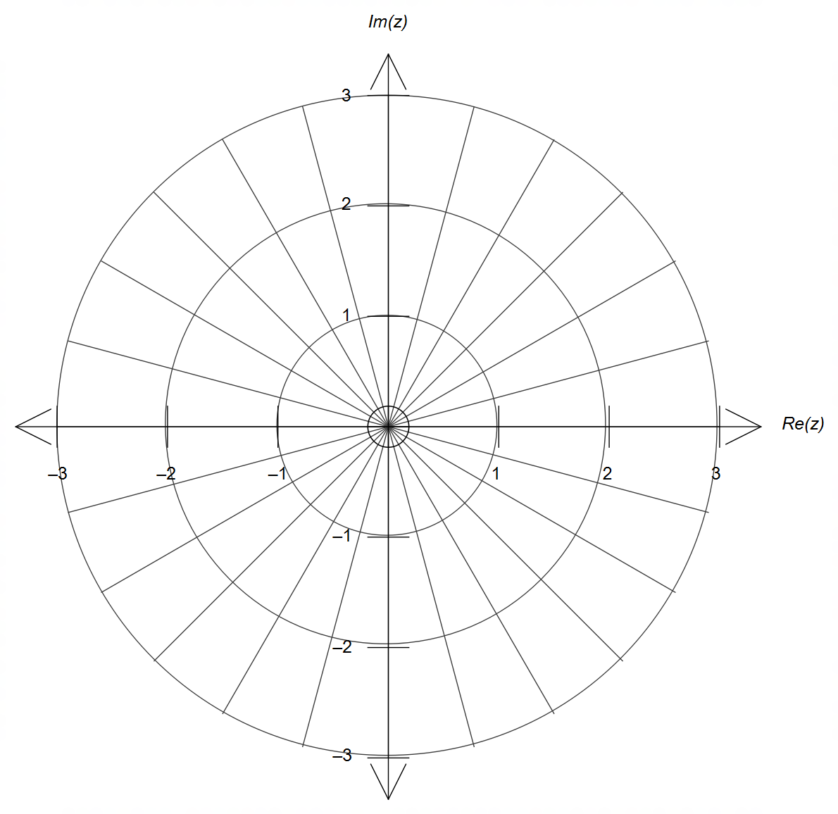

(c) The solutions form the outline of a regular shape.
Determine the exact perimeter of this regular shape. (3 marks)

Question 3 (6 marks)

Consider the planes given by the equations below, where $a∈R$.

$$\begin{matrix}2x+y-2=11 \\ x+2y-3z=17 \\ 3x+y+az=21\end{matrix}$$

When a matrix is used, a simplified format of their coefficients is given below.

$$\left[ \begin{matrix}\begin{matrix}2 & 1\end{matrix} & \begin{matrix}-2 & 11\end{matrix} \\ \begin{matrix}0 & 3\end{matrix} & \begin{matrix}-4 & 23\end{matrix} \\ \begin{matrix}0 & 0\end{matrix} & \begin{matrix}3a+7 & 25\end{matrix}\end{matrix} \right]$$

State the value(s) of $a$ so that the three planes

(a) do not intersect at a single point. (2 marks)

(b) intersect at a unique solution, and hence determine the coordinates of the point
of intersection in terms of $a$. (4 marks)

Question 4 (10 marks)

The function $f(x)$ is defined at $f\left(x\right)=\sqrt{4-x}-1$ and its graph is shown below.

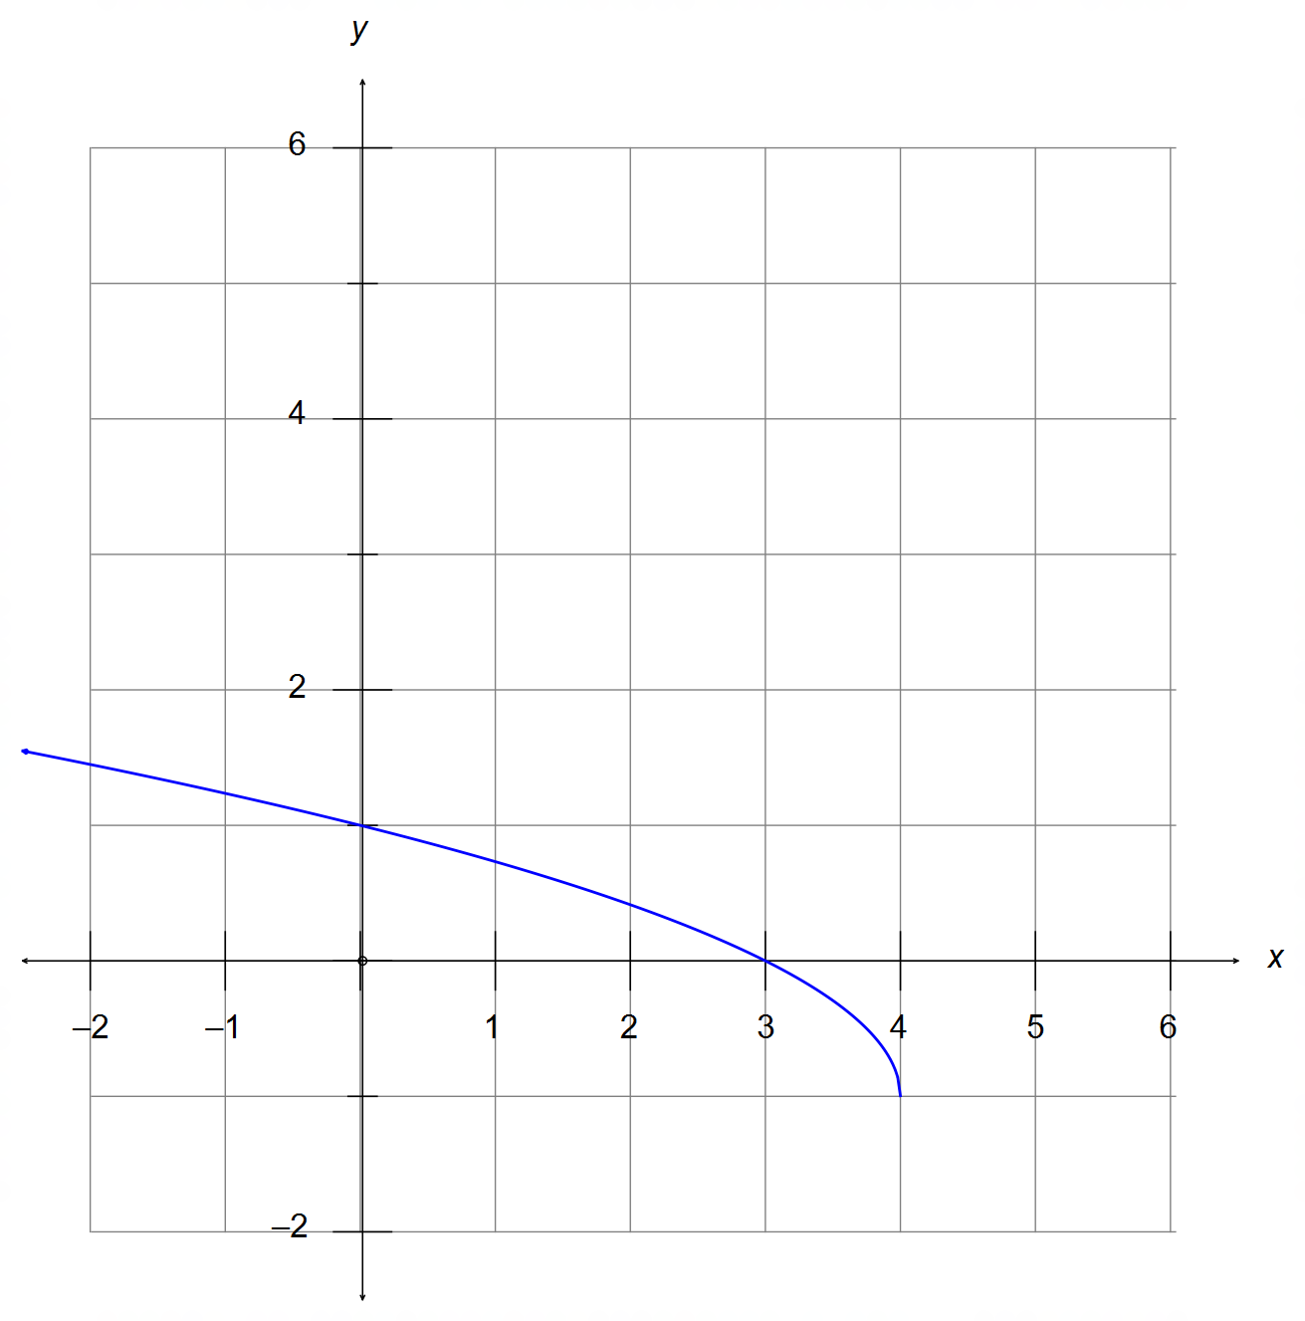

(a) Sketch the graph of $f^{-1}(x)$ on the same grid above. (2 marks)

(b) Determine the equation of $f^{-1}(x)$ and state its domain. (3 marks)

Question 4 – Continued

The function $g(x)$ is defined as $g\left(x\right)=4-x^{2}$.

(c) Determine an expression for $f∘g(x)$. (1 mark)

(d) Does the domain of $g(x)$ need to be adjusted for $f∘g(x)$ to exist? Justify your answer,
and determine the corresponding range of the composition.
(4 marks)

Question 5 (12 marks)

A right rectangular prism, with square base OGEF, is shown below.
Point O is the origin and points F, G, C have respective position vectors $3i, 3j$ and $2k$.

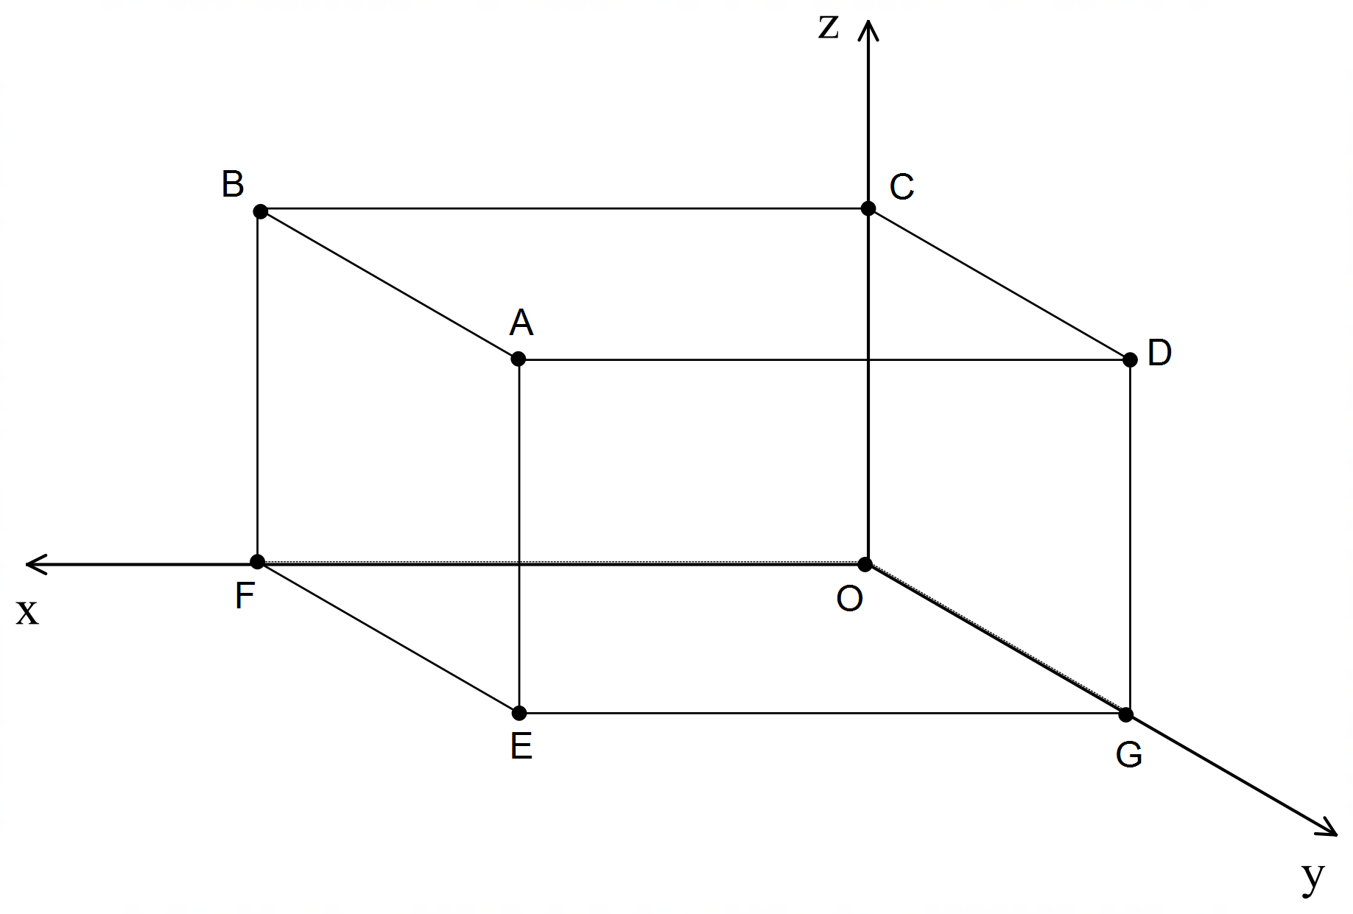

(a) Determine the vector equation of the line that passes through F and D. (2 marks)

(b) Determine the Cartesian equation of the plane perpendicular to FD that passes through A.

(3 marks)

Question 5 – Continued

(c) Determine the point of intersection between the line in (a) and the plane in (b). (3 marks)

(d) The sphere given by $\left|\left(x-a\right)i+\left(y-b\right)j+\left(z-c\right)k\right|=p$ has FD as its diameter.
Determine the value of the real constants $a,b,c$ and $p$. (4 marks)

Question 6 (5 marks)

Sketch the function $y=\frac{x^{2} + x + 2}{x + 1}$ on the grid below, clearly stating its main graphical features.

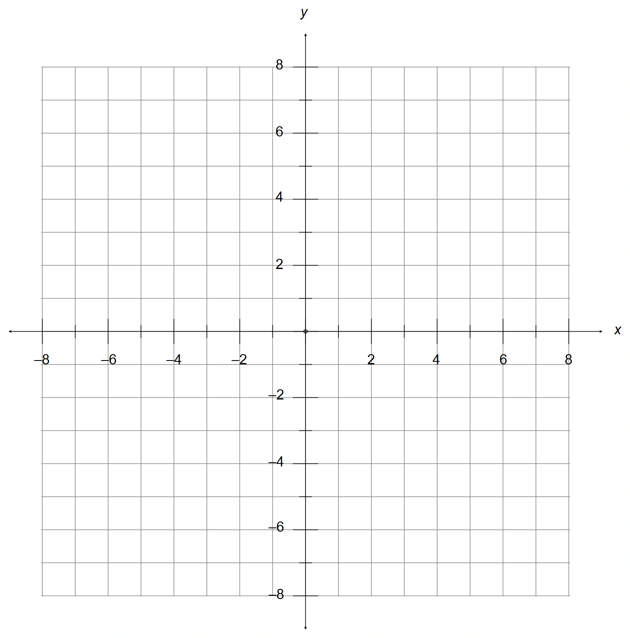

(5 marks)

Question 7 (5 marks)

The complex number $z=k\sqrt{3}+ik$ is defined for $k∈R, k≠0$.

(a) Find a simplified expression for the modulus of $z$ in terms of $k$. (1 mark)

(b) Determine the value of the argument of $z$. [Hint: consider $k>0$ and $k<0$] (2 marks)

(c) The argument of $\frac{z}{i}$. [Hint: consider $k>0$ and $k<0$] (2 marks)

Additional working space
End of Section One

Question number(s): ……………………

Additional working space

Question number(s): ……………………

Additional working space

Question number(s): ……………………

Additional working space

Question number(s): ……………………

Additional working space

Question number(s): ……………………

